Taking multiple inputs from user in Python

Developer often wants a user to enter multiple values or inputs in one line. In C++/C user can take multiple inputs in one line using scanf but in Python user can take multiple values or inputs in one line by two methods.

* Using split() method
* Using List comprehension

**Using**[**split()**](https://www.geeksforgeeks.org/python-string-split/)**method :**  
This function helps in getting a multiple inputs from user . It breaks the given input by the specified separator. If separator is not provided then any white space is a separator. Generally, user use a split() method to split a Python string but one can used it in taking multiple input.

**Syntax :**

input().split(separator, maxsplit)

**Example :**

|  |
| --- |
| # Python program showing how to  # multiple input using split    # taking two inputs at a time  x, y = input("Enter a two value: ").split()  print("Number of boys: ", x)  print("Number of girls: ", y)  print()    # taking three inputs at a time  x, y, z = input("Enter a three value: ").split()  print("Total number of students: ", x)  print("Number of boys is : ", y)  print("Number of girls is : ", z)  print()    # taking two inputs at a time  a, b = input("Enter a two value: ").split()  print("First number is {} and second number is {}".format(a, b))  print()    # taking multiple inputs at a time  # and type casting using list() function  x = list(map(int, input("Enter a multiple value: ").split()))  print("List of students: ", x) |

**Output:**  
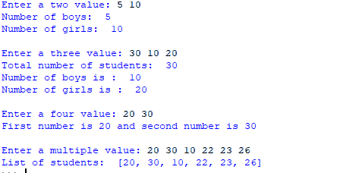  
   
**Using**[**List comprehension**](https://www.geeksforgeeks.org/python-list-comprehension-and-slicing/)**:**  
List comprehension is an elegant way to define and create list in Python. We can create lists just like mathematical statements in one line only. It is also used in getting multiple inputs from a user.

**Example:**

|  |
| --- |
| # Python program showing  # how to take multiple input  # using List comprehension    # taking two input at a time  x, y = [int(x) for x in input("Enter two value: ").split()]  print("First Number is: ", x)  print("Second Number is: ", y)  print()    # taking three input at a time  x, y, z = [int(x) for x in input("Enter three value: ").split()]  print("First Number is: ", x)  print("Second Number is: ", y)  print("Third Number is: ", z)  print()    # taking two inputs at a time  x, y = [int(x) for x in input("Enter two value: ").split()]  print("First number is {} and second number is {}".format(x, y))  print()    # taking multiple inputs at a time  x = [int(x) for x in input("Enter multiple value: ").split()]  print("Number of list is: ", x) |

**Output :**  
